**Big Data Competition**

**Health Equity Data Set**

Mike Roylance, David Crockett

**Introduction (Health Equity)**

We have provided Claim data for our members and we want you to predict when our members need to add money to their HSA accounts.

You can include any other data sources you like to make a case to show why people should add money to their HSA accounts at a given time.  Using age/location can make a difference in the prediction as well.

**Solution Provided**

Predictions for whether a member should add money to their account, and how much, can be seen here:

<http://ec2-107-20-54-170.compute-1.amazonaws.com/HealthEquity/Home/NewMemberPredictions>

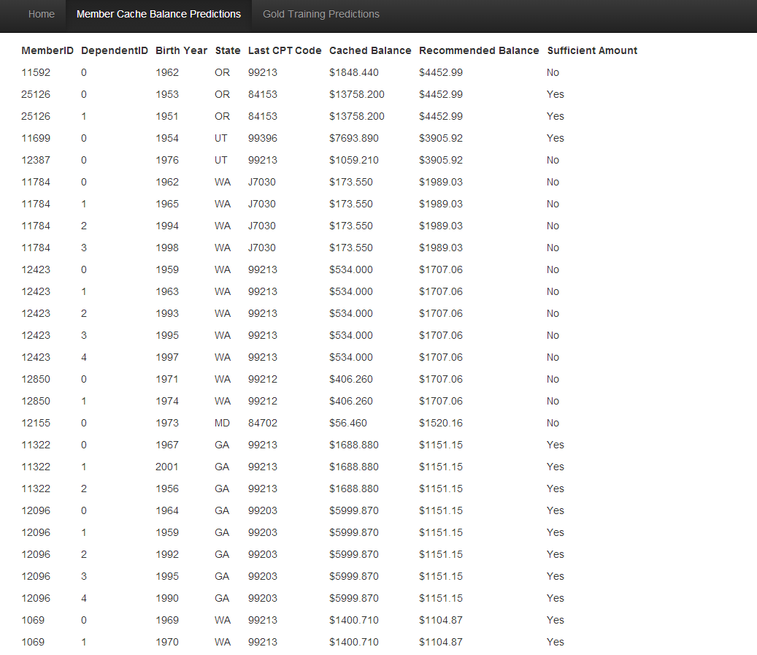

We have also uploaded a query system:

<http://ec2-107-20-54-170.compute-1.amazonaws.com/HealthEquity/>

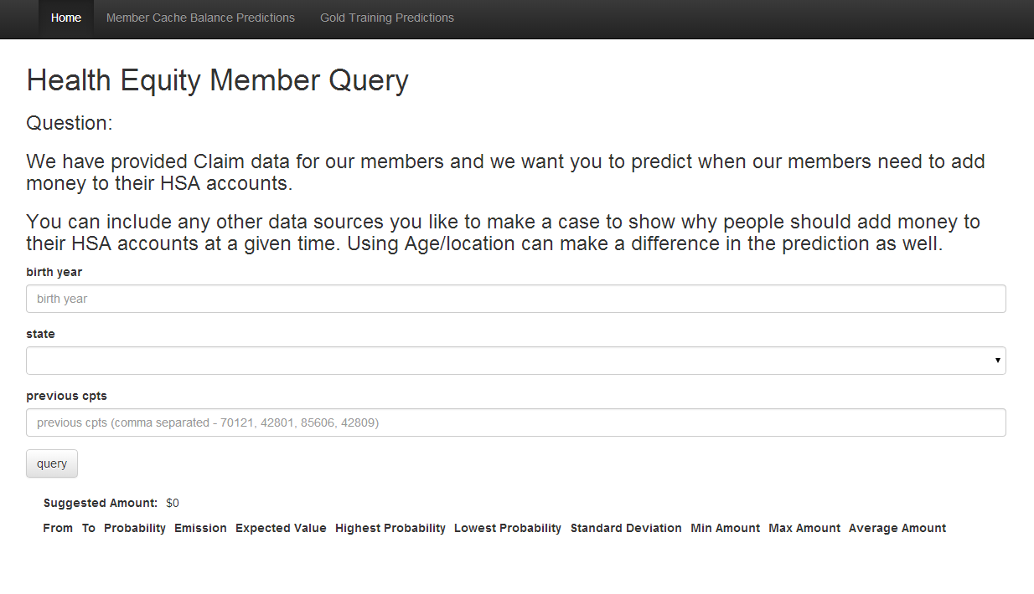

**Methods Used**

First, we decided to look how money came out of the system.

As members receive services, Health Equity receives information about what type of service was rendered (CPTCode), how much it cost the insurance company (RepricedAmount), how much it cost the member (PatientResponsibilityAmount), and when it ended (ServiceEnd). These tuples of information exist in an ordered sequence of time. Our thinking is that patterns will emerge in these sequences that will be useful.

To determine when a person should add money into their account, we want to predict what the next service and costs might likely be.

First, we decided to track the CPT codes. However, CPT codes are too granular to be useful, so grouping the CPT codes together seemed to make sense. After speaking with Braond Nichols at the hackathon event, we decided to use a grouping set provided by The Healthcare Cost and Utilization Project (HCUP).

<http://www.hcup-us.ahrq.gov/toolssoftware/ccs_svcsproc/ccscpt_license.jsp>

We produced a dictionary of CPT codes to CCS codes from the grouping set.

Next, we denormalized the Claim, ClaimDetail, Member and Dependent data into a single csv file containing the proper columns:

NewMemberID, DependentID, CPTCode, CCSCode, PatientResponsibilityAmount, RepricedAmount, BirthYear, Gender, Zip, State, ClaimType, ServiceStart, ServiceEnd

This information was ordered by NewMemberID, then DependentID, then ServiceEnd – all ascending.

With this new csv file, we then built a few dictionaries:

Transition – the transition dictionary looks at each person (which is a composite key of NewMemberID and DependentID) and records that the transition happened. This starts at the person’s first service rendered and builds a transition to the next service rendered until there are no more. This also builds into each transition grouping elements BirthYear (3 groups, under 30, under 60 and over 60) and Location (state). Each record is considered 1 occurrence, the probabilities are calculated at the end. For example, a standard transition will look like this:

**Under60_169 -> Under60_147 : 0.013157894736842105**

The probabilities are calculated after all the transitions have been counted up.

Emission – the emission dictionary looks at each bigram transition and records the amount and probabilities similar to the Transition dictionary. An example record looks like this:

**Under30_231_Under30_240 -> 1425.22 : 0.0008103727714748784**

While the Transition and Emission dictionaries are being built, a small sample (3%) is omitted from the training dictionary and placed in a gold set. This gold set will be used to test the training set.

With the dictionaries built, the gold set is then tested. The results can be seen on the webpage:

<http://ec2-107-20-54-170.compute-1.amazonaws.com/HealthEquity/Home/PredictResults>

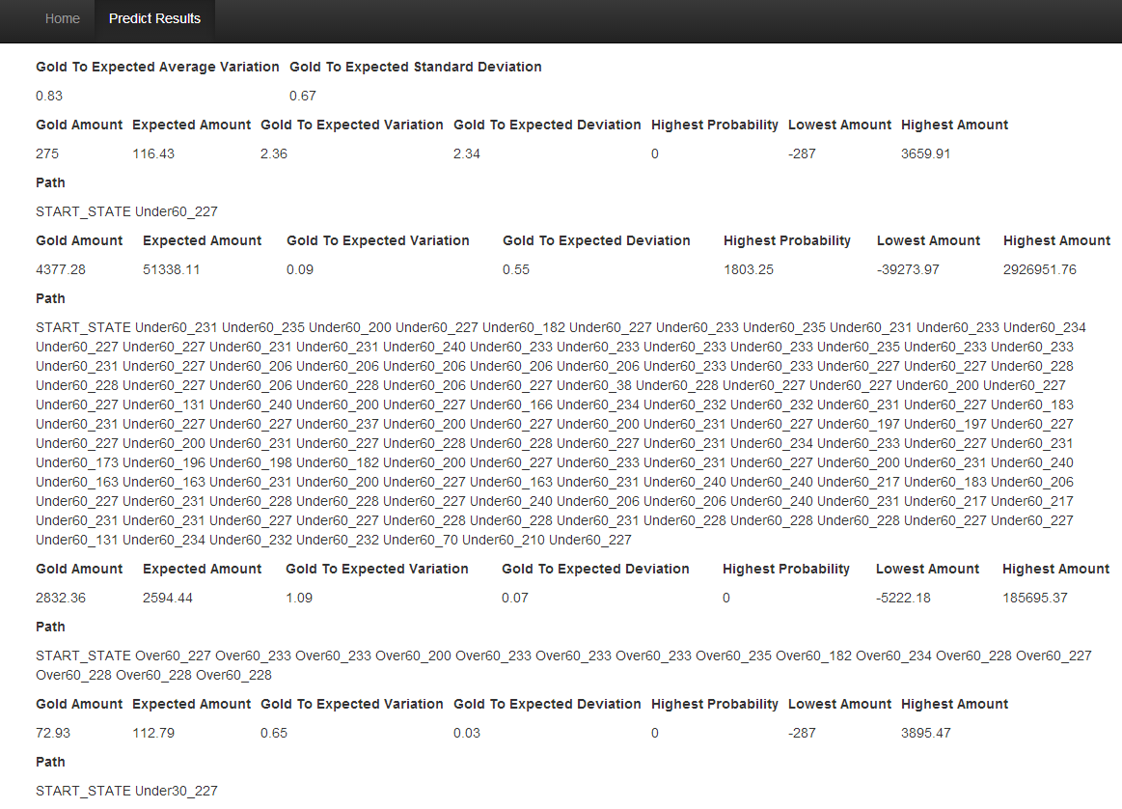

(Figure 1)

For each sequence in the gold set, the amount that’s recorded from each transition is compared against the expected amount (Expected Value) from the dictionaries.

In Figure 1:

**Overall Results:**

**Gold to Expected Average Variation** refers to the average value of Gold Amount / Expected Amount. This method predicted that, on average, Gold Amount was 83% of the Expected Amount.

**Gold to Expected Standard Deviation** refers to the standard deviation of the **Gold to Expected Average Variation** calculation. While the average was 83%, the standard deviation was quite large at .63. This meant that most of the results were within 20% to 146% of the expected amount.

**Gold Amount** refers to the actual amount recorded in the gold set.

**Expected Amount** refers to each amount recorded multiplied by its probability of occurring.

**Gold to Expected Variation** the result of Gold / Expected.

**Gold to Expected Deviation** the result of Gold / Expected – Average.

**Highest Probability** refers to the amount that has the highest probability of occurring.

**Lowest Amount** refers to the lowest amount found.

**Highest Amount** refers to the highest amount found.

We then built a page that allows a user to query the specific results of a person given an age, location and preceding CPT codes:

<http://ec2-107-20-54-170.compute-1.amazonaws.com/HealthEquity>

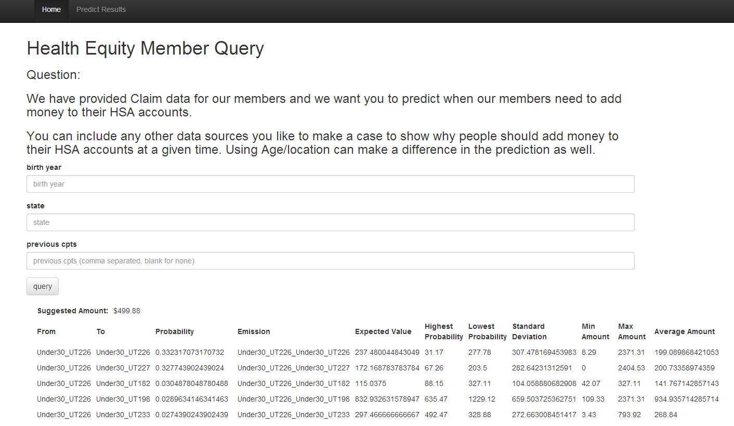

(Figure 2)

Finally, we then calculated the expected amount that each member should have (based on their last known CPT code) and indicated whether or not they should add money to their account.



(Figure 3)

**Future Considerations**

**Different Transition Groupings**

Zip codes are grouped together nation-wide into geographic blocks and boundaries known as Hospital Service Areas (smaller size) and Hospital Referral Regions (larger size) (from Dartmouth Atlas). National CMS benchmarks/stats are available per region for metrics such as average readmission rates, average disease burden, average reimbursement, average diabetes rate, average deaths from heart attacks, etc.

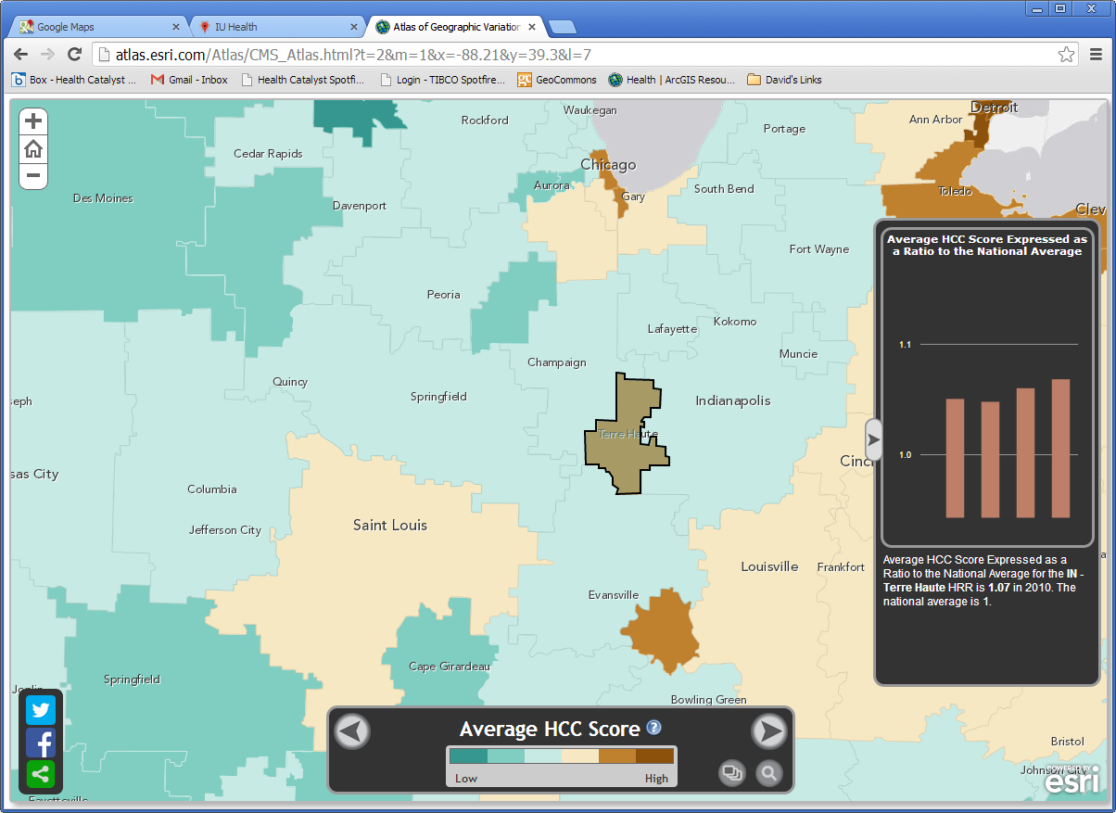

Claims data can be mapped per zip code and easily compared within and between two or more health service regions.

Hospitals and other health facilities (clinics, surgery centers, imaging, rehab, and hospice) can also be mapped per each region.

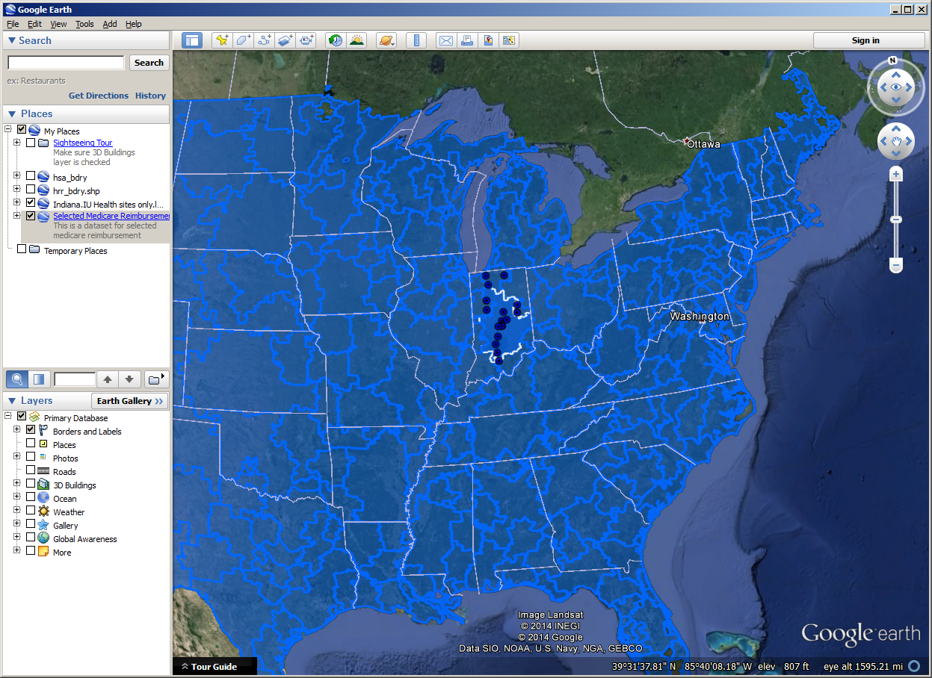

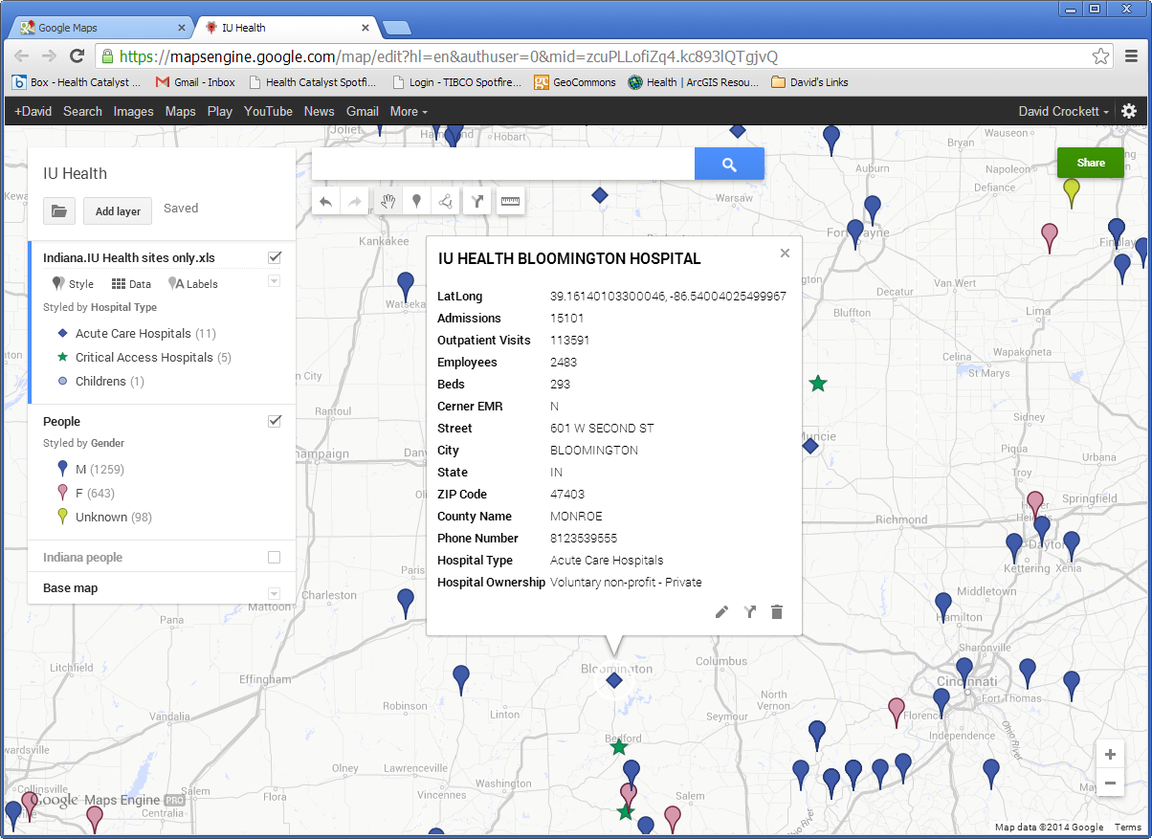

It would be good to experiment with different combinations of age / location grouping, as well as gender.

**Finish Calculations**

The member calculations need to be completed, we only calculated a few thousand.

**Introduce Time**

It would be good to experiment with better time amounts. Currently, we don’t include the exact time between transitions.